* **Introduction of the topic**

Aim : Develope a CLI based application for Bus travelling service using JAVA8 , MYSQL database and JDBC.

Working options :

* + - 1. When anyone open CLI application (run java code) , initially it shows 4 options –

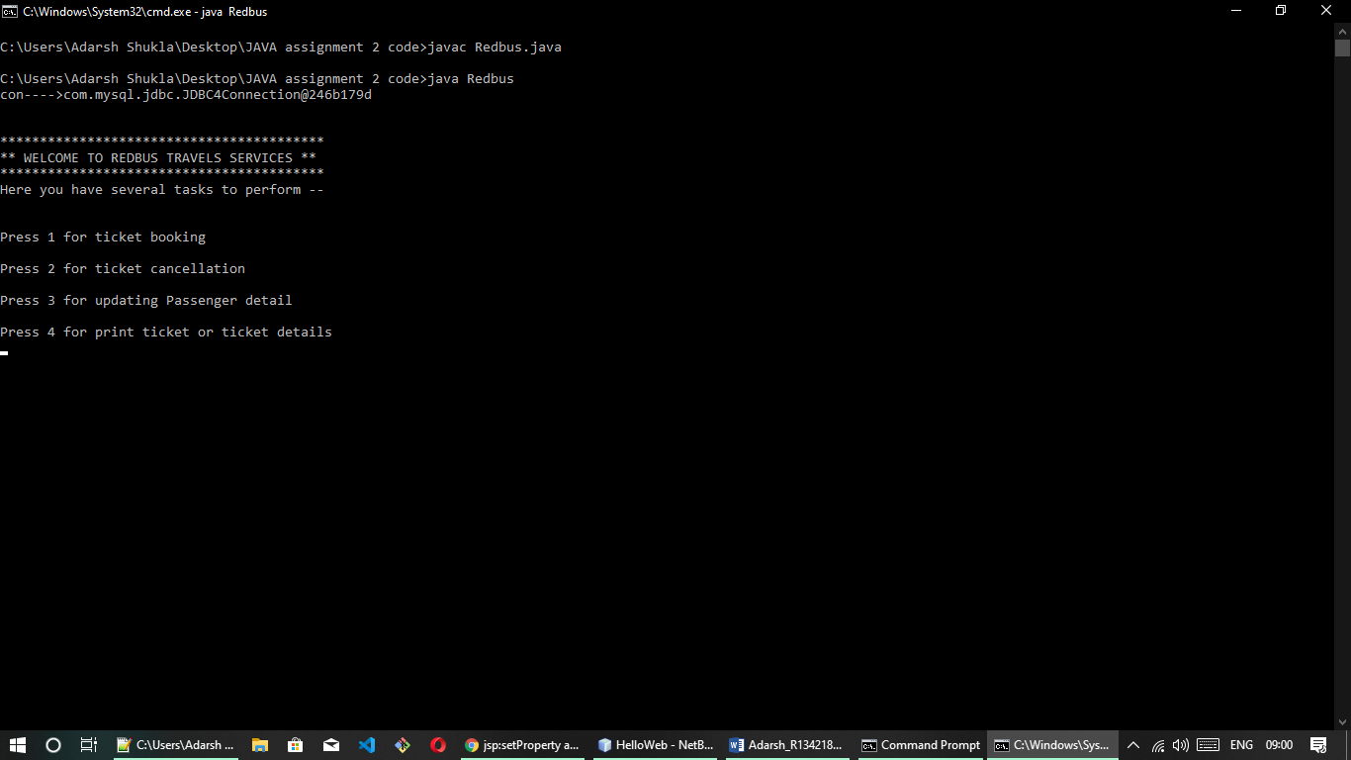

* **Suppose user want to book ticket**

*(Steps)*

* + - * 1. Passenger can book ticket on 2 routes –

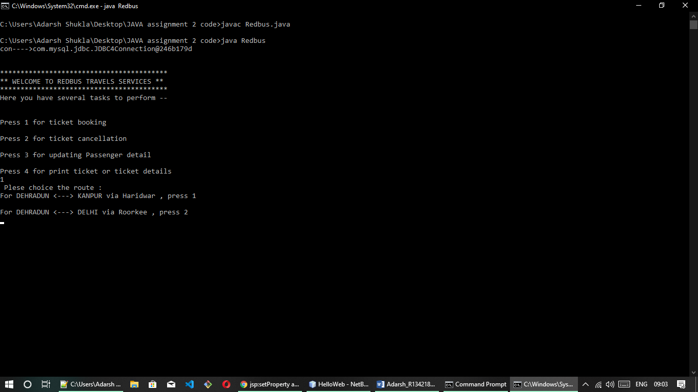

* + - * 1. After choosing route, passenger will fill required detail. (Journey date, Passenger Name and Age, Source city, Destination city, Bus type, Seat type etc.)
        2. On the basis of detail, application will sort out the buses.
        3. Here, user will get a list of buses with various detail (like- Arrival time , Departure time etc.)
        4. Select bus.
        5. Now, user will reach on payment page.
        6. Apllication have 3 methods to do payment –

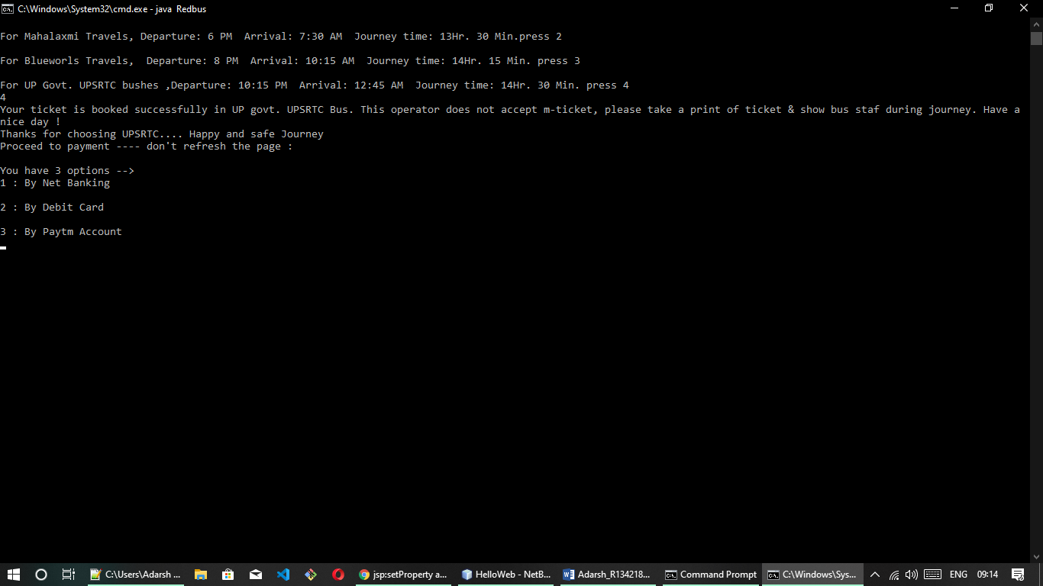

* + - * 1. Select any one method and give required credentials.
        2. Now, user will get confirmation of successful ticket booking.
* **Suppose user want to cancel ticket**

*(Steps)*

1. Select bus in which you want to cancel your ticket :

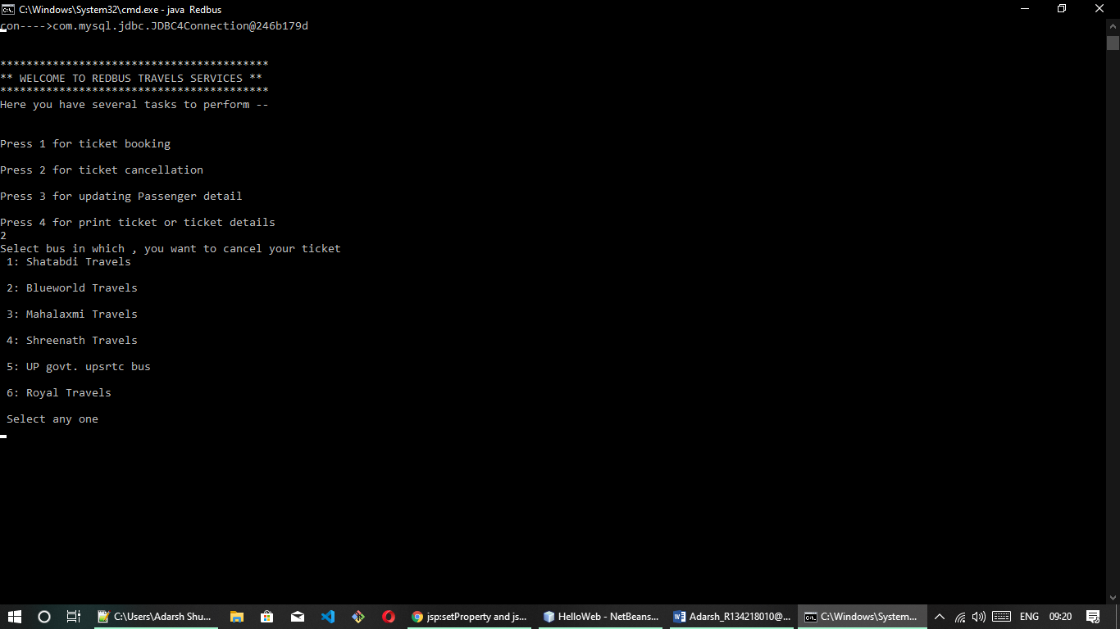

1. Select bus and give required detail (i.e. Email et.).

1. Application search ticket and cancel it.
2. Now, user will get confirmation of successful ticket cancellation.

* **Suppose user want to update passenger detail**

*(Steps)*

1. Select bus in which you want to update data in your ticket :



1. Select bus and give required detail to search ticket

(i.e. Email et.).

1. Give detail which will changes in ticket (like- name and age etc.)

1. Application search and update it.
2. Now, user will get confirmation of successful ticket updation.

* **Suppose user want to print ticket detail**

*(Steps)*

1. Select bus in which you want to print your ticket :



1. Select bus and give required detail to search ticket

(i.e. Email, Journey date et.).

1. Application search ticket and print it on command prompt.